**Journal Report 23**

**02/22/2024**

I spent class time finding some more examples of anomalies. I didn’t make significant progress in this class because there are a small number of anomalies within the dataset itself and I was experimenting with the hyperparameter tuning. It was essentially a repetition of the tasks I did throughout the week as I found that the examples I found before didn’t exhibit clear anomalies.

The main task that I finished was hyperparameter tuning for my forecast model. It can be improved, but I decided that the prediction in and of itself doesn’t have to be perfect. I should be able to compensate for the overfitting and lack of noise within my voltage prediction by having my anomaly detection aggregators have bigger thresholds. This would essentially account for the larger amount of noise present in the actual time series.

**02/25/2024**

I researched some of the specifics of the anomaly threshold model and analyzed other implementations. I am planning to set an upper and lower boundary for each variable so that anomalous behavior can be easily identified. However, the main problem I see is finding the actual boundary. I believe it will take some time to fiddle with the number in order to get the correct threshold. I am definitely planning to do this process on multiple time series and then average the values in order to find a generalizable threshold for the variable in general.

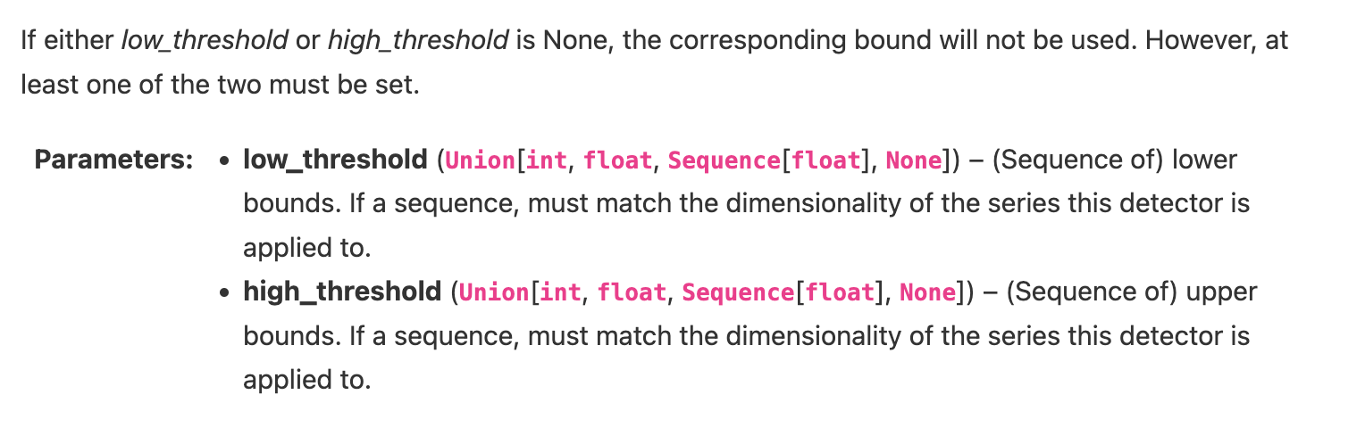

**02/27/2024**

I spent the class time annotating my time series. I am creating a new time series with each time stamp indicating 1 or 0. This is a very tedious process and I was able to do this for 2 time series. I am aiming to complete 5 by Friday. Afterwards, I began implementing the threshold detection model, but am still finding different ways to find the optimal threshold values. The progress for threshold detection is going smoothly and the next steps include feeding the inputs and creating code to graph the output. I feel that graphically showing the results will take the longest.